1. **Create a simple Angular application that displays "Hello, Angular!" on the screen. Follow the steps below:**

**• Create a new component named hello-angular.**

**• Modify the hello-angular component to display the message "Hello, Angular!" using data binding.**

**• Include the hello-angular component in the AppComponent to display the message in the browser.**

**Step – 1: Create a new angular application**

**ng new myfirst**

**Step – 2: Create a new Component**

**ng generate component hello-angular**

**Step – 3: Serve the application**

**ng serve**

**open your browser and go to** [**http://localhost:4200/**](http://localhost:4200/) **to see the angular application.**

**index.html**

<!doctype html>

<html lang="en">

<head>

  <meta charset="utf-8">

  <title>Myfirst</title>

  <base href="/">

  <meta name="viewport" content="width=device-width, initial-scale=1">

  <link rel="icon" type="image/x-icon" href="favicon.ico">

</head>

<body>

  <app-root></app-root>

</body>

</html>

**src/app/hello-angular/hello-angular.component.ts**

import { Component } from '@angular/core';

@Component({

  selector: 'app-hello-angular',

  imports: [],

  template: '<h1>{{message}}</h1>',

  styleUrl: './hello-angular.component.css'

})

export class HelloAngularComponent {

  message: string = 'Hello Angular!';

}

**src/app/hello-angular/hello-angular.component.html**

<h1>{{message}}</h1>

**src/app/hello-angular/hello-angular.component.css**

h1{

    color: blue;

    text-align: center;

    font-weight: bold;

    font-size: xx-large;

}

**Output:**

1. **Create an Angular application to demonstrate two-way data binding. The application should allow a user to input text in a textbox, and the text should dynamically update and display below the textbox.**

**• Create a component named dynamic-binding.**

**• In the dynamic-binding component, use [(ngModel)] to bind a variable to the textbox input field and display the variable's value dynamically below the textbox.**

**src\app\dynamicbinding \dynamicbinding.component.html**

<div>

    <h3>Two way data binding </h3>

    <input type="text" [(ngModel)]="userInput" placeholder="Type Something Here...."/>

    <p>Youu typed: {{userInput}}</p>

</div>

**src\app\dynamicbinding\dynamicbinding.component.ts**

import { Component } from '@angular/core';

@Component({

selector: 'app-dynamicbinding',

standalone: false,

templateUrl: './dynamicbinding.component.html',

styleUrl: './dynamicbinding.component.css'

})

export class DynamicbindingComponent {

userInput: string = '';

}

**src\app\app.component**

<app-dynamicbinding></app-dynamicbinding>

**Output:**

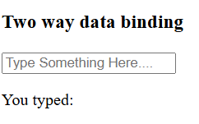

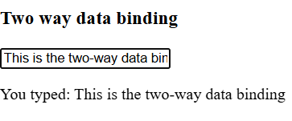

1. **Conditional Rendering with *ngIf**

**• Create an Angular application that displays a button labeled "Toggle Message."**

**• When the button is clicked, toggle the visibility of a message "Hello, this is a conditional message!" using the *ngIf directive.**

**src\app\app.component.html**

<div style="text-align: center; margin-top: 50px;">

  <button (click)="toogleMessage1()">Toogle Message</button>

  <p *ngIf="isMessageVisible">Hello, this is a conditional message</p>

</div>

**src\app\app.component.css**

button {

    margin: 20px;

    padding: 10px 20px;

    font-size: 16px;

  }

  p {

    font-size: 18px;

    color: red;

    font-weight: bold;

    font-family: 'Times New Roman', Times, serif;

  }

**src\app\app.component.ts**

import { Component } from '@angular/core';

@Component({

  selector: 'app-root',

  templateUrl: './app.component.html',

  standalone: false,

  styleUrl: './app.component.css'

})

export class AppComponent {

  title = 'toogleMessage1';

  isMessageVisible: boolean = false;

  toogleMessage1(){

    this.isMessageVisible = !this.isMessageVisible;

  }}

**Output:**

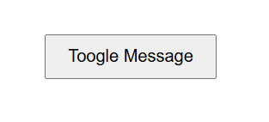

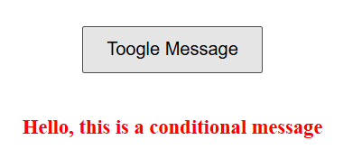

1. **Using *ngFor for Displaying a List**

• **Create an Angular application to display a list of student names dynamically.**

• **Use the *ngFor directive to loop through an array of student names and display them as a list in the browser.**

• **Include a button to add a new name to the list.**

**src/app/student-list/student-list.component.html**

<h2>Student list</h2>

<ul>

    <li *ngFor="let student of students Names">{{students}}</li>

</ul>

<input

type="text"[(ngModel)]="newStudent" placeholder="Enter a new student name"/>

<button (click)="addStudent()">Add Student</button>

**src/app/student-list/student-list.component.css**

h2 {

    color: #2c3e50;

  }

  ul {

    list-style-type: none;

    padding: 0;

  }

  li {

    background: #ecf0f1;

    margin: 5px 0;

    padding: 10px;

    border-radius: 5px;

  }

  input {

    margin-right: 10px;

    border-color: black;

  }

  button{

    border-color: black;

    font-weight: bold;

    }

**src/app/student-list/student-list.component.ts**

import { Component } from '@angular/core';

@Component({

  selector: 'app-student-list',

  standalone: false,

  templateUrl: './student-list.component.html',

  styleUrl: './student-list.component.css'

})

export class StudentListComponent {

  students: string[] = ['Rahul','Carol','Brian'];

  newStudent: string = '';

  addStudent(){

    if(this.newStudent.trim()){

      this.students.push(this.newStudent.trim());

      this.newStudent = '';

    }

  }

}

**src/app/app.component.html**

<app-student-list></app-student-list>

**Output:**

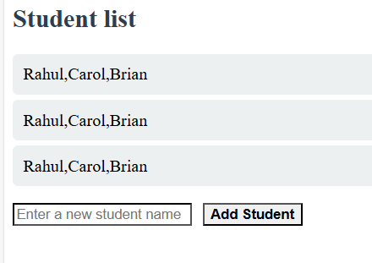

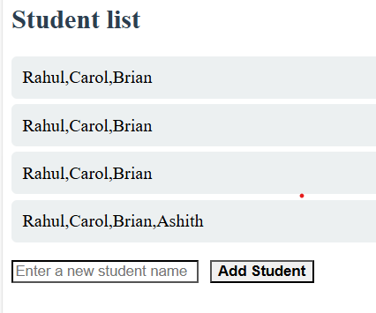

1. **Program Title: Displaying Day of the Week Using *ngSwitch Create an Angular application that displays the name of the day based on a number input (1 to 7).**

**src/app/day-display/day-display.component.html**

<div>

    <h2>Enter a number (1-7) to get the day of the week</h2>

    <input type="number" [(ngModel)]="dayNumber" min="1" max="7"/>

    <div [ngSwitch]="dayNumber">

        <div *ngSwitchCase="1">Monday</div>

        <div *ngSwitchCase="2">Tuesday</div>

        <div *ngSwitchCase="3">Wednesday</div>

        <div *ngSwitchCase="4">Thursday</div>

        <div *ngSwitchCase="5">Friday</div>

        <div *ngSwitchCase="6">Saturday</div>

        <div *ngSwitchCase="7">Sunday</div>

        <div *ngSwitchDefault>Please enter a number between 1 to 7</div>

    </div>

</div>

**src/app/day-display/day-display.component.ts**

import { Component } from '@angular/core';

@Component({

  selector: 'app-day-display',

  standalone: false,

  templateUrl: './day-display.component.html',

  styleUrl: './day-display.component.css'

})

export class DayDisplayComponent {

  dayNumber: number = 1;

}

**src/app/app.component.html**

<h1>Day of the week Dispaly</h1>

<app-day-display></app-day-display>

**Output:**

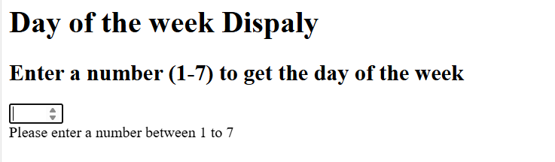

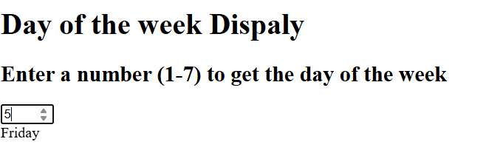

1. **Develop an Angular program to create a simple to-do list application. Allow users to add, edit, and delete tasks. Note: The default values for tasks may be included in the program.**

**src/app/todo/todo.component.html**

<div class="todo-container">

    <h1>To-Do List</h1>

    <input [(ngModel)]="newTaskTitle" placeholder="Add a new task" />&nbsp; &nbsp;

    <button (click)="editTaskId ? updateTask() : addTask()">

      {{ editTaskId ? 'Update Task' : 'Add Task' }}

    </button>

    <ul>

      <li *ngFor="let task of tasks">

        <input type="checkbox" [(ngModel)]="task.completed" (change)="toogleCompletion(task)" />

        <span [class.completed]="task.completed">{{ task.title }}</span>

        <button (click)="editTask(task)">Edit</button>

        <button (click)="deleteTask(task.id)">Delete</button>

      </li>

    </ul>

  </div>

**src/app/todo/todo.component.ts**

import { Component } from '@angular/core';

import { Task } from './task.model';

import { title } from 'process';

@Component({

  selector: 'app-todo',

  standalone: false,

  templateUrl: './todo.component.html',

  styleUrl: './todo.component.css'

})

export class TodoComponent {

  tasks: Task[]=[

    {id: 1, title: 'Learn Angular', completed:false},

    {id: 2, title: 'Build a To-Do App', completed: false},

  ];

  newTaskTitle: string ='';

  editTaskId: number | null = null;

  addTask(){

    if(this.newTaskTitle.trim()){

      const newTask: Task ={

        id: this.tasks.length+1,

        title:this.newTaskTitle,

        completed:false,

      };

      this.tasks.push(newTask);

      this.newTaskTitle  = '';

    }

  }

  editTask(task: Task){

    this.editTaskId = task.id;

    this.newTaskTitle=task.title;

  }

  updateTask(){

    if(this.editTaskId!=null){

      const task = this.tasks.find(t=>t.id == this.editTaskId);

      if(task){

        task.title = this.newTaskTitle;

        this.newTaskTitle='';

        this.editTaskId=null;

      }

    }

  }

  deleteTask(taskId: number){

    this.tasks = this.tasks.filter(task => task.id!=taskId);

  }

toogleCompletion(task: Task){

  task.completed = !task.completed;

}

  }

**src/app/app.component.html**

<app-todo></app-todo>

**Output:**

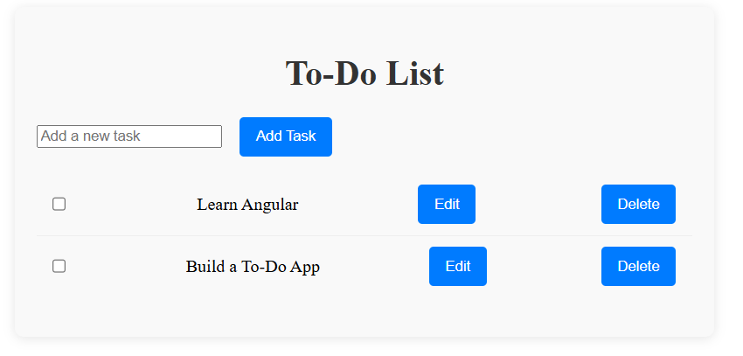

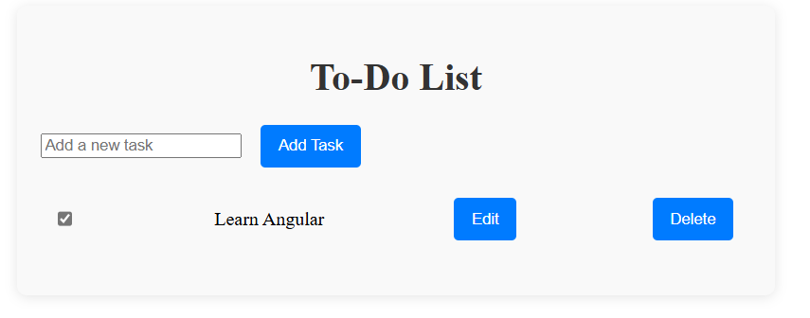

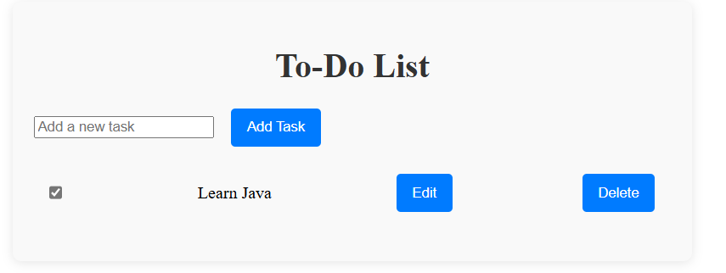

1. **Angular Pipes**

• **Create Angular application to convert student details to Uppercase using angular filters. Note: The default details of students may be included in the program.**

• **Create an Angular application that displays the date by using date filter parameters.**

**src/app/date-display/date-display.component.html**

<h2>Current Date</h2>

<p>Default Format: {{ currentDate | date }}</p>

<p>Short Date: {{ currentDate | date:'shortDate' }}</p>

<p>Medium Date: {{ currentDate | date:'mediumDate' }}</p>

<p>Long Date: {{ currentDate | date:'longDate' }}</p>

<p>Custom Format: {{ currentDate | date:'yyyy-MM-dd HH:mm:ss' }}</p>

**src/app/date-display/date-display.component.css**

h2 {

    color: #007bff;

    margin-top: 20px;

  }

  p {

    background: #fff;

    margin: 10px 0;

    padding: 10px;

    border-radius: 5px;

    box-shadow: 0 2px 5px rgba(0, 0, 0, 0.1);

  }

**src/app/date-display/date-display.component.ts**

import { Component } from '@angular/core';

@Component({

  selector: 'app-date-display',

  standalone: false,

  templateUrl: './date-display.component.html',

  styleUrl: './date-display.component.css'

})

export class DateDisplayComponent {

  currentDate: Date = new Date();

}

**src/app/student-details/student-details.component.html**

<h2>Student Details</h2>

<ul>

  <li *ngFor="let student of students">

    Name: {{ student.name | uppercase }} | Age: {{ student.age }} | Course: {{ student.course | uppercase }}

  </li>

</ul>

**src/app/student-details/student-details.component.css**

h2 {

    color: #007bff;

    margin-top: 20px;

  }

  ul {

    list-style-type: none;

    padding: 0;

  }

  li {

    background: #fff;

    margin: 10px 0;

    padding: 10px;

    border-radius: 5px;

    box-shadow: 0 2px 5px rgba(0, 0, 0, 0.1);

  }

**src/app/student-details/student-details.component.ts**

import { Component } from '@angular/core';

@Component({

  selector: 'app-student-details',

  standalone: false,

  templateUrl: './student-details.component.html',

  styleUrl: './student-details.component.css'

})

export class StudentDetailsComponent {

  students = [

    { name: 'Rahul', age:'25', course:'Msc'},

    { name: 'Carol', age:'23', course:'MCA'},

    { name: 'Brian', age:'20', course:'MBA'}

  ];}

**src/app/app.component.html**

<h1>Student Details Application</h1>

<app-student-details></app-student-details>

<app-date-display></app-date-display>

**Output:**

